# user manual or instruction guide

(1)Before you start testing the code, port the Test_data and source_code folders completely to a new python project.



(2)Configure the corresponding python library according to the library requirements in source_code.

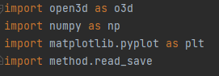

(3)In addition, change the read path of the program in all test_data to a local absolute or relative path.

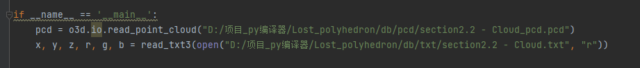

(4)Now you can try running program in source_code, in the following order:

A_rgb_destiny_cluster.py

B_mainwaypoint.py

C_undirected_rootpoint.py

D_route_plan_cluster.py

E_route_plan_all.py

F_globall_view.py

G_rough_plan_all.py

